First Universalist Church, Unitarian Universalist
Auburn, ME
Board of Directors
Meeting Minutes
March 6, 2024
Bonnie Soper Room
Present: Anne Perron (President), David Das (Clerk), Jane Pentheny (member-at-large), John Spruill (member-at-large), Reverend Patrick McLaughlin (ex officio).
Excused Absences: Linda Greathouse, Claire Hebert
Guests: Holly Cooney, Levesque
7:08: Anne Perron called the meeting to order.
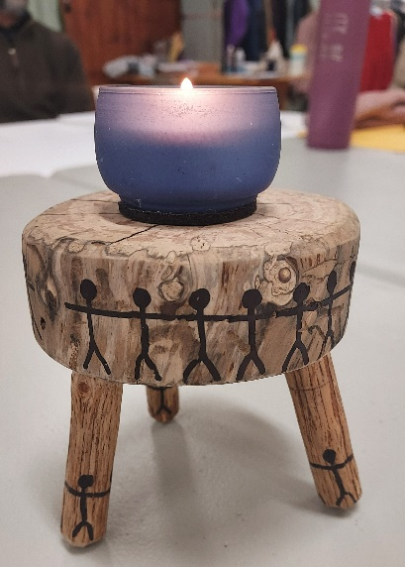
John read the Mission Statement.
Jane read a section from the “Covenant for Auburn UU Board of Directors” from the Board Policy Manual.
Anne lit the chalice; she called on all of us to work together to create and strengthen community.

Brief sharing by Board members.
Board Chalice

Minister’s Report:
- Lord Shiva continues to:
  - giveth: sewer crisis resolved at 159 Pleasant St.
  - taketh away: fridge died at 159 Pleasant St.
- Otherwise, a quiet 2 weeks
President’s Report:
- Anonymous donation to cover full cost of sewer repair at 159 Pleasant St (both current and planned).
- Received card from congregation member suggesting idea of an Easter brunch. Theme: “Come Home to Church.” Patrick will speak with Luke about arrangements.
Board Member Communications:
- None
Consent Agenda:
- February 21, 2024 Minutes
Motion to approve: John
Second: Jane
Unanimous approval.
Open Session:
- Holly:
  - proposed idea of a Plant Sale as a fundraiser. Looking at an outside event. May 31; rain date as June 7. Will work with Toby on communication. Board enthusiastically in support.
  - Brief update on covenant conversation process:
    - Broadening reach by contacting all those in the Directory to see where they are with their relationship to the Church.
    - Meetings have gone well: a fun process. Struck by the importance of the personal connection – the human link – as a motivation to come to church.
Annual Meeting:
- Board set June 9 as the date for the Annual Meeting
- Board set June 2 as the date for a Town Hall to review the 2024-25 budget.
- David will inform Toby of the dates.

Rose Window Award Nominations:
- May 29 as the deadline.
- John to connect with Toby on getting the word out.

Staff Contract Templates:
- Patrick gave a brief overview of progress in creating a standardized template.
  - Looked to Maine state requirements:
    - 13 legal holidays
    - 2 weeks vacation (pro-rated)
    - 1 week sick leave
  - Will bring updated contracts to the Board.

Committee Budget Requests:
- Committees need to submit 2024-25 budget requests to Finance and to the Board.
- Anne and Greg B. will work on the process.

Building Safety Policy:
- Made edits to the General Safety Policy and the Fire Evacuation Protocol. To be voted upon at the March 20, 2024 Board meeting.
- Armed Intruder Protocol put on hold as the State of Maine is developing an advisory protocol.

8:50 Adjournment

Respectfully submitted,
David H. Das (Clerk)

